**EE3731C Programming Assignment Report**

**Name:** Lim Yu Guang **Matriculation Number:** A0172618B

**Q1. Mapping Between Character and Double Arrays**

1. 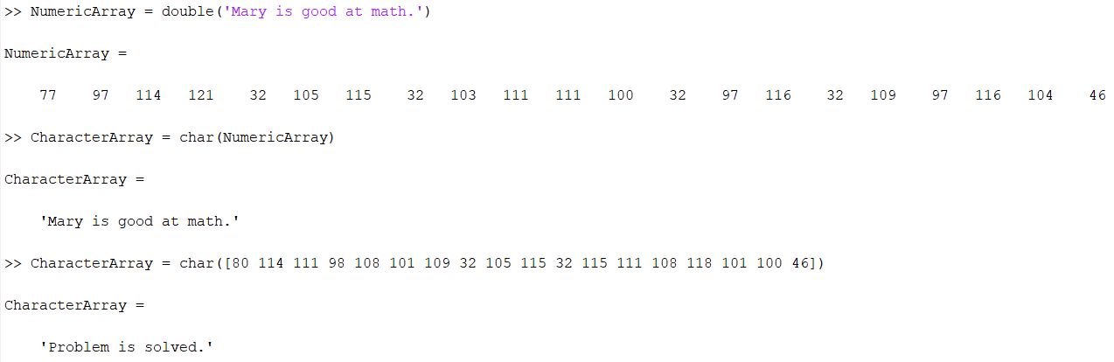

**Figure 1. MATLAB results for question 1(a)**

1. 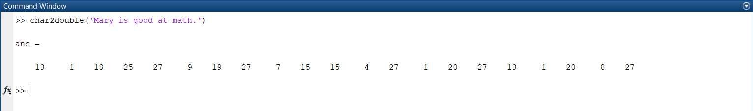

**Figure 2. MATLAB results for question 1(b)**

1. 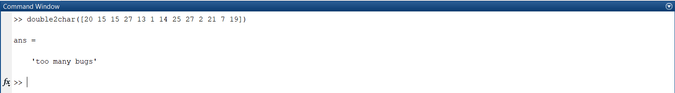

**Figure 3. MATLAB results for question 1(c)**

**Q2. Encrypting/Decrypting A Message**

1. 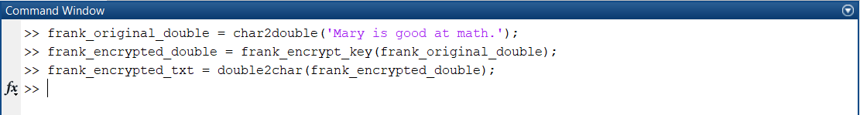

**Figure 4. MATLAB commands to encrypt ‘Mary is a good at math.’**

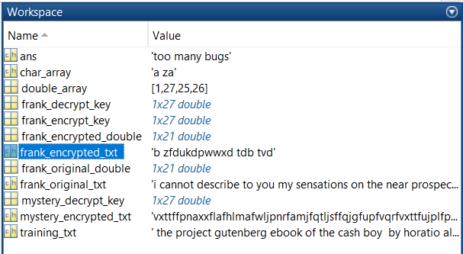

**Figure 5. MATLAB results for question 2(a)**

With reference to figure 5, the result for question 2(a) is ‘b zfdukdpwwxd tdb tvd’.

1. 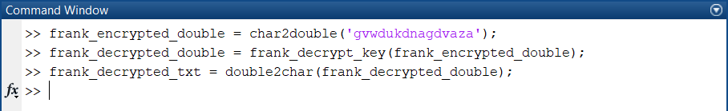

**Figure 6. MATLAB commands to decrypt ‘gvwdukdnagdvaza’**

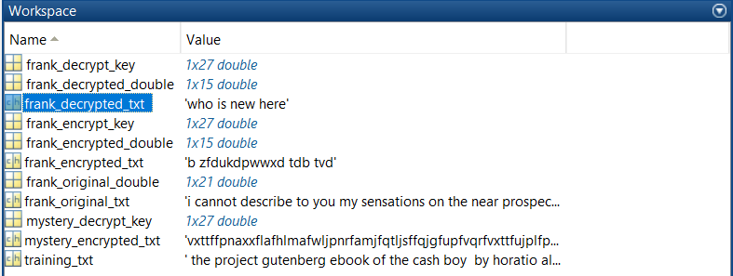

**Figure 7. MATLAB results for question 2(b)**

With reference to figure 7, the result for question 2(b) is ‘who is new here’.

**Q3. Probability of Consecutive Characters**

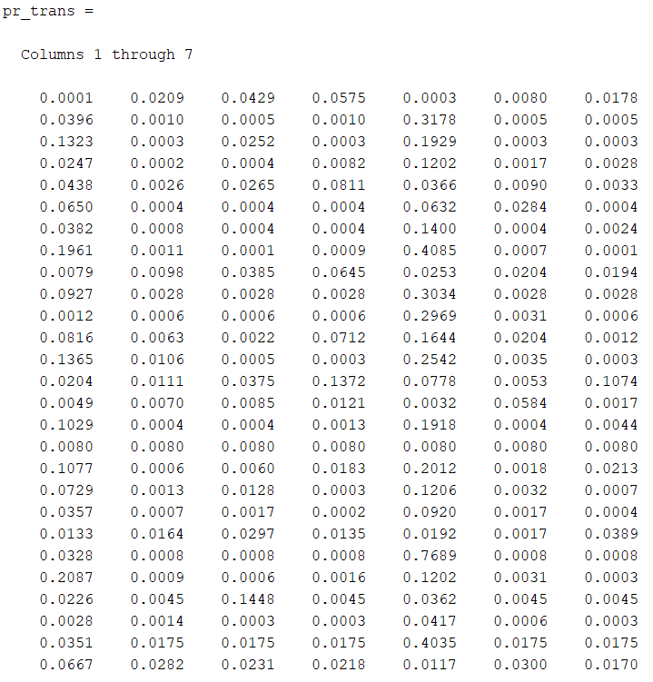

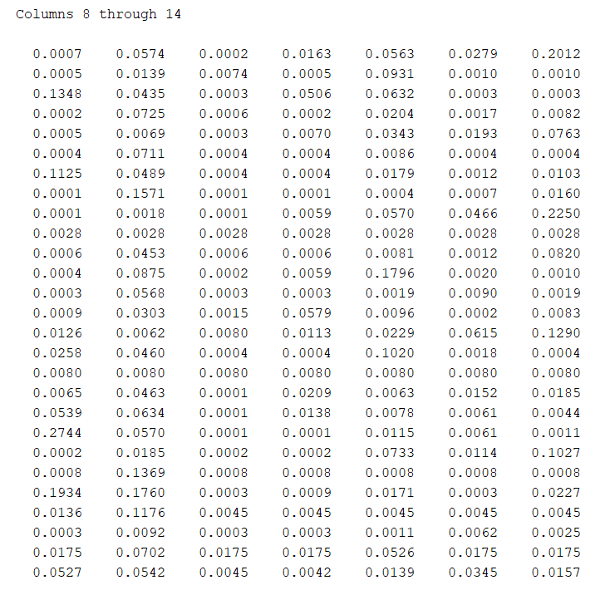

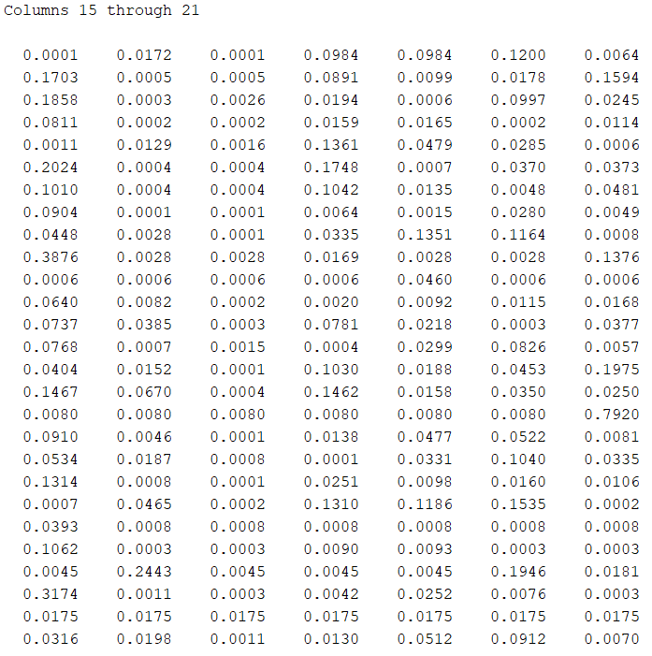

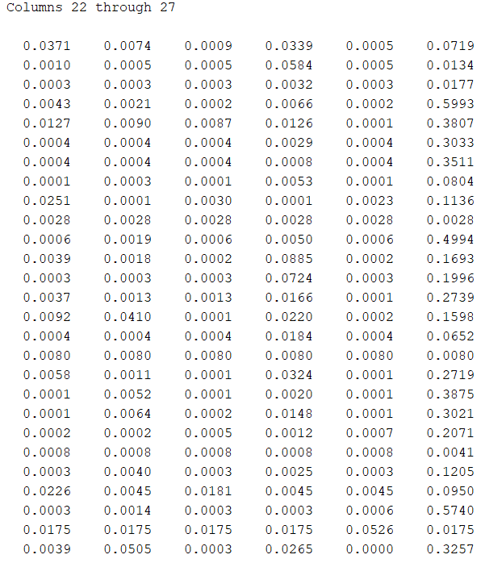

**Figure 8. MATLAB results for question 3(a)**

pr_trans(1,1) = 9.8020e-05 and pr_trans(2,3) = 4.9505e-04

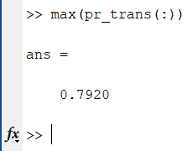

**Figure 9. Highest probability of pr_trans**

With reference to figure 9, the highest probability is 0.7920 located at pr_trans(17,21). The alphabetical transition of the highest probability is when present, i = q and future, j = u.

1. 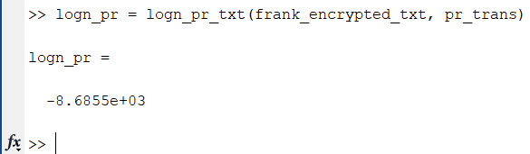

**Figure 10. logn_pr of frank_encrypted_txt**

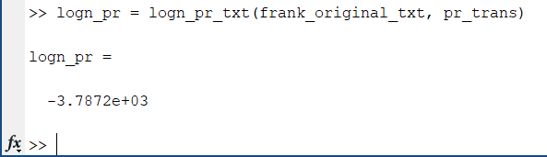

**Figure 11. logn_pr of frank_original_txt**

1. 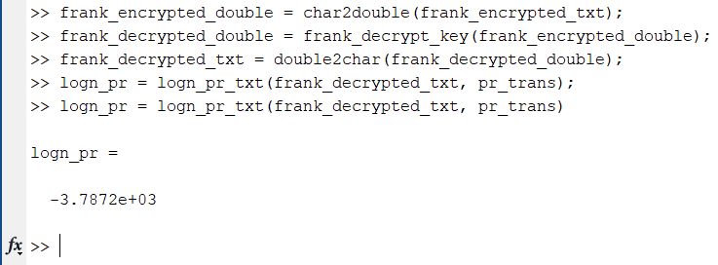

**Figure 12. Natural logarithm of p(frank_encrypted_txt | frank_decrypt_key)**

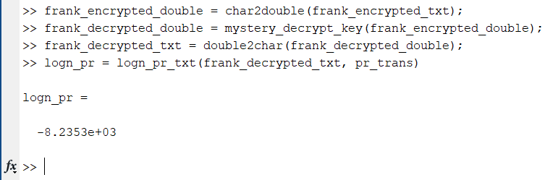

**Figure 13. Natural logarithm of p(frank_encrypted_txt | mystery_decrypt_key)**

**Q4. Metropolis Algorithm**

1. (i)

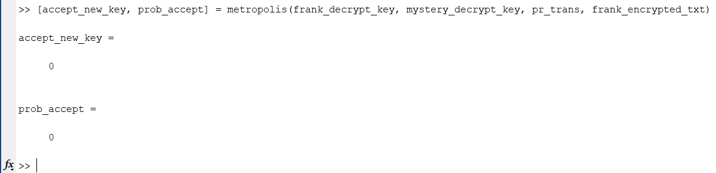

**Figure 14. MATLAB results for question 4(a)(i) using mystery_decrypt_key as the new key**

(ii)

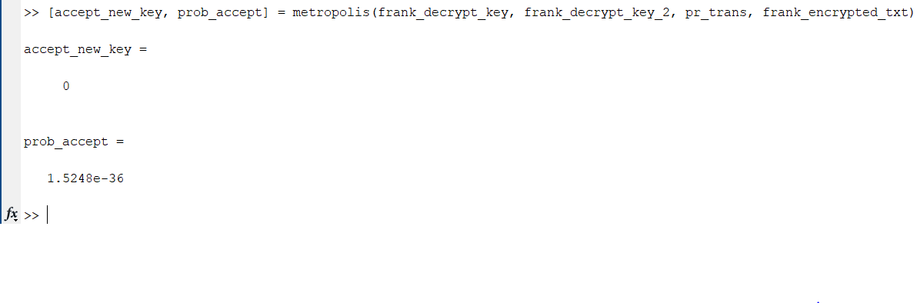

**Figure 15. MATLAB results for question 4(a)(ii) using frank_decrypt_key with 12th and 13th element swapped as the new key**

1. Run 15000: log probability = -3790.7192

**Final decrypted text**

i cannot describe to you my sensations on the near prospect of my undertaking it is impossible to communicate to you a conception of the trembling sensation half pleasurable and half fearful with which i am preparing to depart i am going to unexplored regions to the land of mist and snow but i shall kill no albatross therefore do not be alarmed for my safety or if i should come back to you as worn and woeful as the ancient mariner you will smile at my allusion but i will disclose a secret i have of ten attributed my attachment to my passionate enthusiasm for the dangerous mysteries of ocean to that production of the most imaginative of modern poets there is something at work in my soul which i do not understand i am practically industrious painstaking a workman to execute with perseverance and labour but besides this there is a love for the marvellous a belief in the marvellous intertwined in all my prozects which hurries me out of the common pathways of men even to the wild sea and unvisited regions i am about to explore but to return to dearer considerations shall i meet you again after having traversed immense seas and returned by the most southern cape of africa or america i dare not expect such success yet i cannot bear to look on the reverse of the picture continue for the present to write to me by every opportunity i may receive your letters on some occasions when i need them most to support my spirits i love you very tenderly remember me with affection should you never hear from me again

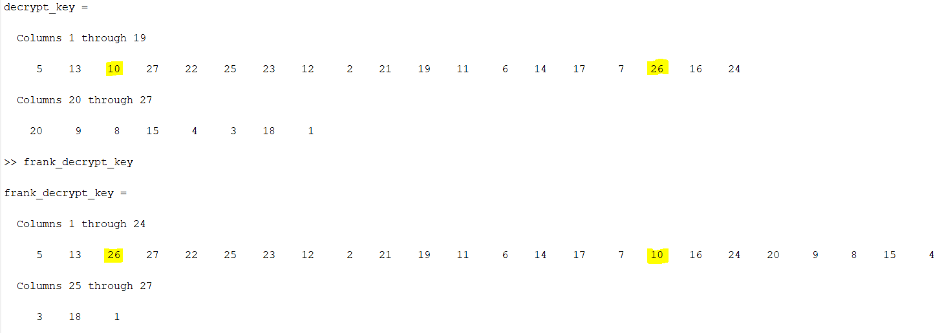

**Figure 16. Comparison of the generated decrypt_key and frank_decrypt_key**

As seen in figure 16, frank_decrypt_key differs from the generated decrypt_key at column 3 and 17 of the two matrices. In the frank_decrypt_key, letter c is mapped to letter z and letter q is mapped to letter j, whereas, in the generated decrypt_key, letter c is mapped to letter j and letter q is mapped to letter z.

The keys difference result in a different final text because letter c and letter q are not mapped correctly to letter z and letter j respectively. For instance, in the final text, using the generated decrypt_key, there is a wrong word such as ‘prozects’. If frank_decrypt_key is used instead, ‘projects’ will be produced after decryption.

The algorithm does not show up exactly the correct answer because the acceptance of a new key depends on the log_new and log_curr values generated from log_pr_txt.m, which is reliant on the pr_trans generated from the training_txt. As such, the acceptance of a new key indirectly depends on the training_txt being used. In this assignment, the statistical regularity of

normal written English is being exploited to obtain the pr_trans from training_txt. However, the training_txt might not be the best representation of the probabilities of all alphabetical sequences. In addition, using a different set of training_txt with different amount characters will yield a different pr_trans values. As such, the training_txt might not have provided sufficient information to generate the pr_trans which affected the outcome.

1. Run 15000: log probability = -4265.771

**Final decrypted text**

well three or four months run along and it was well into the winter now i had been to school most all the time and could spell and read and write qust a little and could say the multiplication table up to six times seven is thirty five and i don t reckon i could ever get any further than that if i was to live forever i don t take no stock in mathematics anyway at first i hated the school but by and by i got so i could stand it whenever i got uncommon tired i played hookey and the hiding i got next day done me good and cheered me up so the longer i went to school the easier it got to be i was getting sort of used to the widow s ways too and they warn t so raspy on me living in a house and sleeping in a bed pulled on me pretty tight mostly but before the cold weather i used to slide out and sleep in the woods sometimes and so that was a rest to me i liked the old ways best but i was getting so i liked the new ones too a little bit the widow said i was coming along slow but sure and doing very satisfactory she said she warn t ashamed of me one morning i happened to turn over the salt cellar at breakfast i reached for some of it as juick as i could to throw over my left shoulder and keep off the bad luck but miss watson was in ahead of me and crossed me off she says take your hands away huckleberry what a mess you are always making the widow put in a good word for me but that warn t going to keep off the bad luck i knowed that well enough i started out after breakfast feeling worried and shaky and wondering where it was going to fall on me and what it was going to be there is ways to keep off some kinds of bad luck but this wasn t one of them kind so i never tried to do anything but qust poked along low spirited and on the watch out

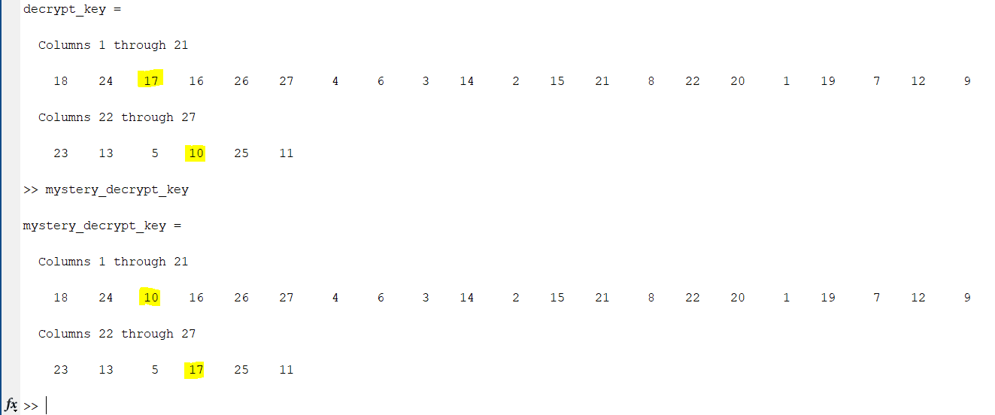

**Figure 17. Comparison of the generated decrypt_key and mystery_decrypt_key**

As observed in figure 17, mystery_decrypt_key differs from decrypt_key at column 3 and 25 of the two matrices. In the mystery_decrypt_key, letter c is mapped to letter j and letter y is mapped to letter q, whereas, in the generated decrypt_key, letter c is mapped to letter q and letter y is mapped to letter j.

The keys difference result in a different final text because letter c and letter y are not map correctly to letter q and letter j respectively. For instance, in the final text, using the generated decrypt_key, there are wrong words such as ‘qust’ and ‘juick’ after decryption. If mystery_decrypt_key is used instead, ‘just’ and ‘quick’ will be produced after decryption.

Similar to the question 4(b), the algorithm does not show up exactly the correct answer because the acceptance of a new key depends on the log_new and log_curr values generated from log_pr_txt.m, which is reliant on the pr_trans generated from the training_txt. As such, the acceptance of a new key indirectly depends on the training_txt being used. In this assignment, the statistical regularity of normal written English is being exploited to obtain the pr_trans from training_txt. However, the training_txt might not be the best representation of the probabilities of all alphabetical sequences. In addition, using a different set of training_txt with different amount characters will yield a different pr_trans values. As such, the training_txt might not have provided sufficient information to generate the pr_trans which affected the outcome.

**Q5. Extra Credits**

Suggestions:

1. In this assignment, only 1 sample is being generated. More samples could have been generated to get the correct decrypt_key. In addition, the rng(5, 'twister') in mcmc_decrypt_text.m has to be removed to generate multiple varying samples. When more samples are generated, we could find the MAP estimate of multiple samples to generate the correct decrypt_key.
2. The number of characters used in the training_txt could be changed or increased to provide a more accurate representation of the pr_trans.
3. The rand(1) model used to accept a new decrypt_key could have been improved. rand(1) consists of numbers within the range of 0 to 1 only. As such, there is chance of accepting a key that is considered not the correct decrypt_key when log_new < log_curr.